Sylvan Summer Day Camp Registration 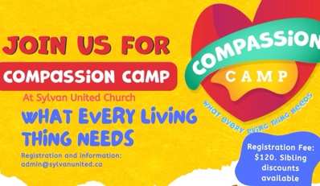
Child’s name

First__________________________________________ Last__________________________

Grade __________ Birthdate______________________________________________

Address_______________________________________________________________________

Parent/Guardian - Contact Information
Parent/Guardian #1

First__________________________________________ Last__________________________

Address_______________________________________________________________________

Cell phone _______________ E-mail __________________________________________

Parent/Guardian #2

First__________________________________________ Last__________________________

Address (if different from above)_______________________________________________________________________

Cell phone _______________ E-mail __________________________________________

Emergency Contact Information — Alternate Pickup/Release
Emergency Contact #1

First__________________________________________ Last__________________________

Address_______________________________________________________________________

Cell phone __________________ E-mail __________________________________________

Emergency Contact #2
First__________________________________________ Last__________________________

Address_______________________________________________________________________

Cell phone __________________ E-mail __________________________________________

Health and Safety

Care Card Number_______________________________________________________________

Does your child have allergies we should know about

If yes, explain:__________________________________________________________________

_____________________________________________________________________________

Does your child have any dietary considerations (ie vegetarian, gluten free etc)

If yes, explain:__________________________________________________________________

_____________________________________________________________________________

Waiver: In all activities there is an element of risk. While Sylvan United Church and it’s volunteers and employees will take all reasonable precautions, this is no guarantee against injury or loss. By signing this form, you release Sylvan United Church, it’s staff and volunteers from all manner of actions, claim and demands whatever nature which result from any loss, injury or expense sustained, arising out of or in any way connected with participation in any program or attendance at a location operated by Sylvan United Church. In the event your child is injured, ill or in need of medical attention and you are unable to be contacted, you authorize Sylvan United Church to seek medical attention on your behalf.

Parent's/Guardian's Signature____________________________________________________

Photo Release: I hereby give permission for my child to be photographed. I understand the photos will be used to keep a journal of activities, to share during power point presentations and/or reports to our donors and for promotional purposes including flyers, brochures, newspaper and on the internet. I understand that although my child's photograph may be used for advertising, his or her identity will not be disclosed,

Parent's/Guardian's Initials_________________________

Camp fee is $120/child, with a discount of 25% for each additional sibling. E-transfers can be sent to admin@sylvanunited.ca Please use the password Compassion. Cheques can be made out to Sylvan United Church
______________________________________________________________________________

Payment method:
Cash
Cheque
E-transfer

Sylvan United Church is an LGBTQ+ Safe Space. All are welcome.
The congregation of Sylvan United Church acknowledges, with respect, our location on traditional lands of the Hul'qumi ‘num People, recognizing especially the Malahat (Malexel) and Cowichan First Nations.
PAYMENT: E transfers to: admin@sylvanunited.ca PW: christmas choir Cheques accepted.

